Implementing clustering algorithms to group the customers.

Applying corresponding strategies to maximize profit and satisfy the needs of the customer.

Identifying the potential customer base for selling the product or applying appropriate offers according to their needs.

Figure 1: Visual representation of customer segmentation.

Figure 2: Types of segmentation

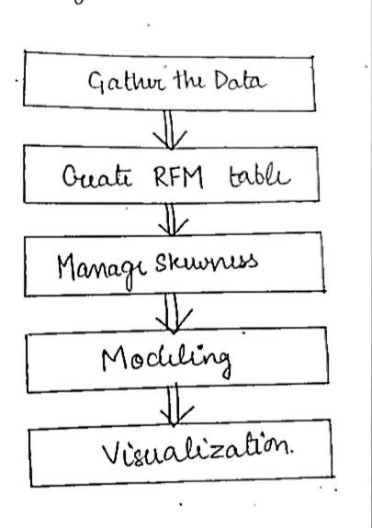

Figure 3: Flow chart for implementing Customer Segmentation model